|  |  |  |
| --- | --- | --- |
| Name | Ali hamdy Ali |  |
| B.N | 523 |  |
| Edu mail | ali195576@feng.bu .edu.eg |  |

# •Title

ComputerEngineeringRoleinCOVID-19Pandemic

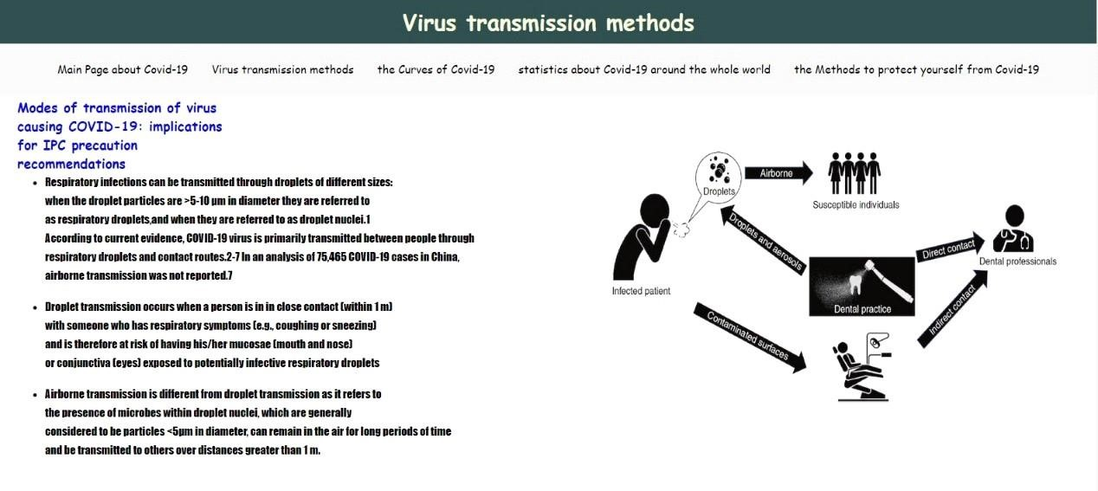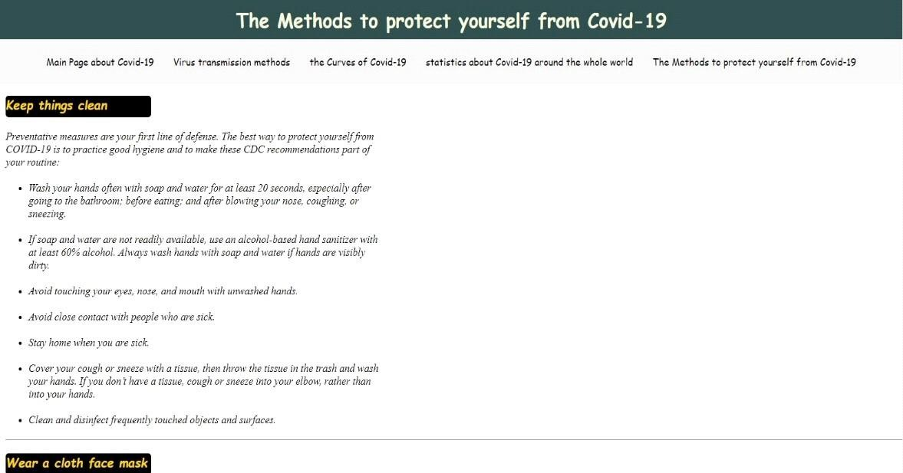

# •Screencode

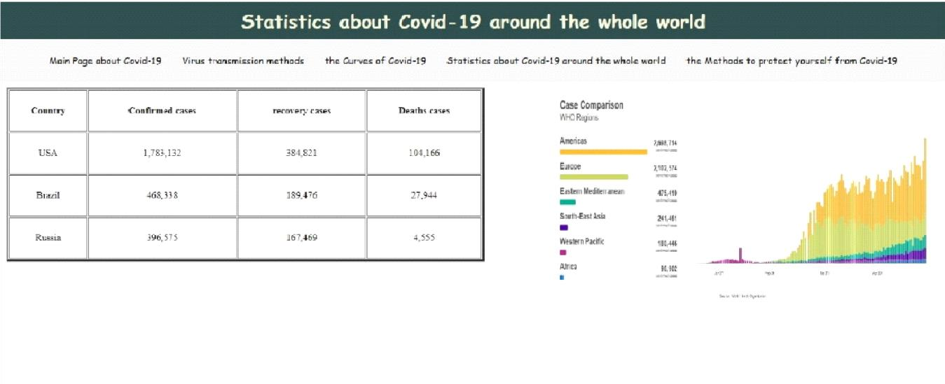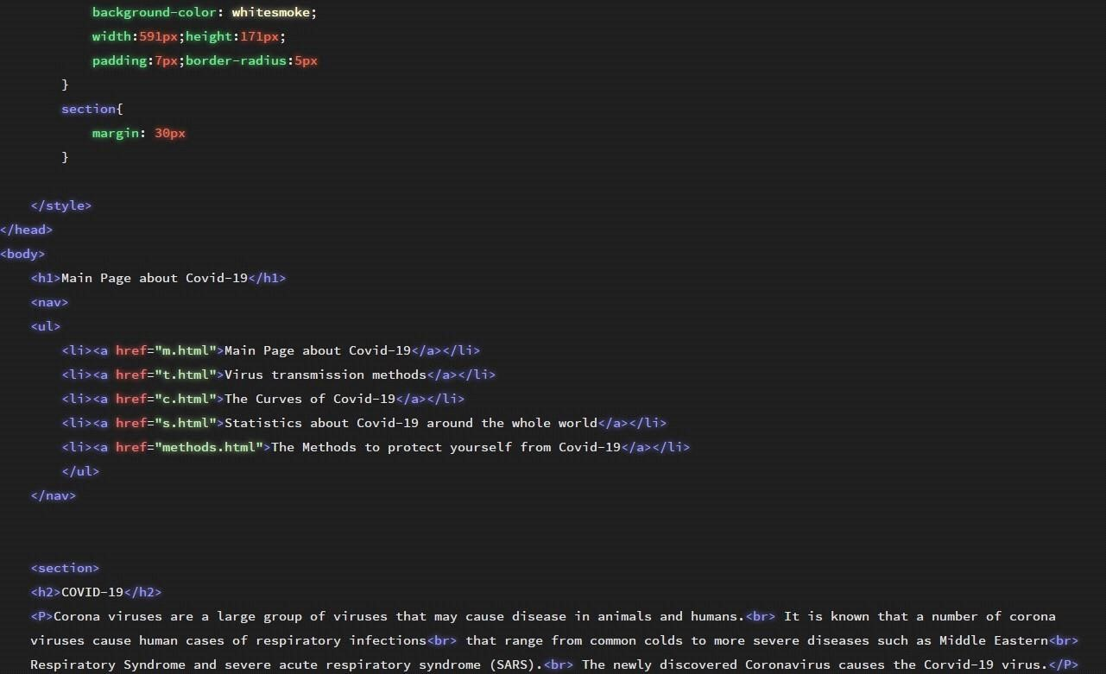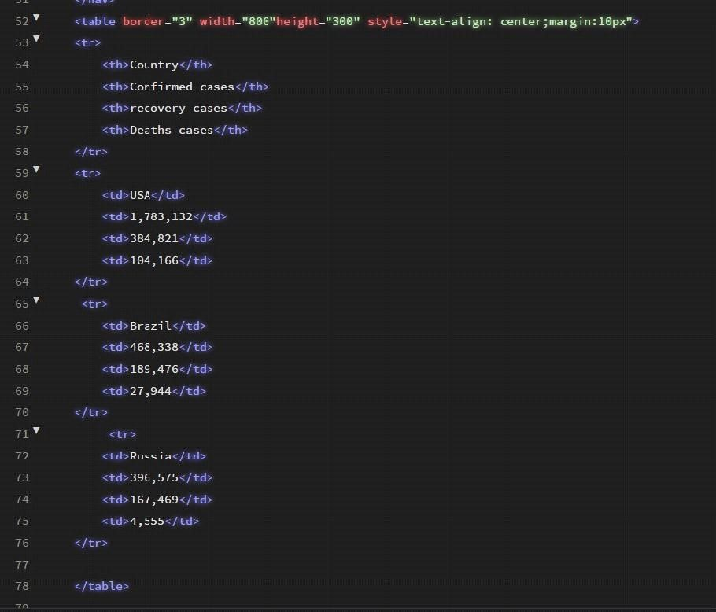

# •Introduction

•InthefaceofCOVID-19,manycaregivers,engineersandgifted amateursaresteppinguptofindwaystosupporthealthcare workers.Tohelpguidesomeoftheseefforts,MichaelBarrow, aPh.D.candidatewith ProfessorRyan Kastner’sresearch groupinthe

ComputerScienceandEngineering Department (CSE)atUCSanDiego,isleadinganeffortto boostcriticalcaremanagementduringtheseuncertaintimes. BarrowisworkingcloselywithShangleiLiu,MD,ageneral surgeonatMayoClinicandtheproject’sclinicalprimary investigator.

AndTheteamisalsoexploringhowclinicianscanaddressthe potentialneedtosimultaneouslyventilatemanypatients.In additiontoCSEandMayoClinic,collaboratorsatMIT,Scuola SuperioreSant'AnnaPisainItalyandseveralprivate companieshavejoinedtheproject.

GitHublink[:https://al518.github.io/HTML.project.repsitory/](https://al518.github.io/HTML.project.repsitory/)

GitHubpage[publishedwebsite]:

<https://github.com/al518/HTML.project.repsitory>